**EXERCISE-2 ANDROID APPLICATION FOR LAYOUT MANAGERS AND EVENT LISTENERS**

To develop a Simple Android Application that uses Layout Managers and Event Listeners.

##### Procedure:

**Creating a New project:**

* Open Android Stdio and then click on **File -> New -> New project.**

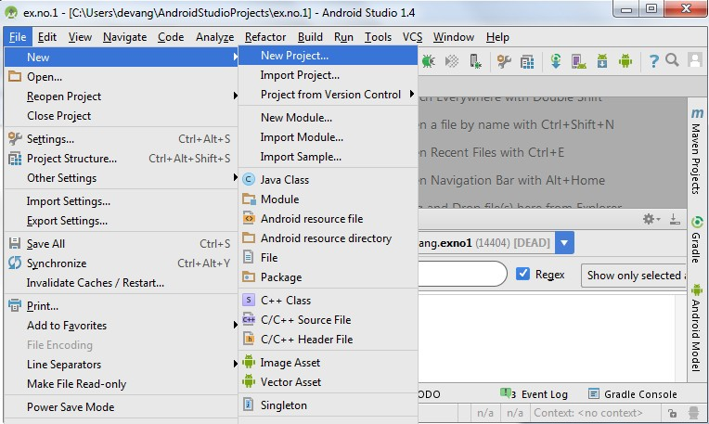

* Then type the Application name as “**ex.no.2″** and click **Next.**

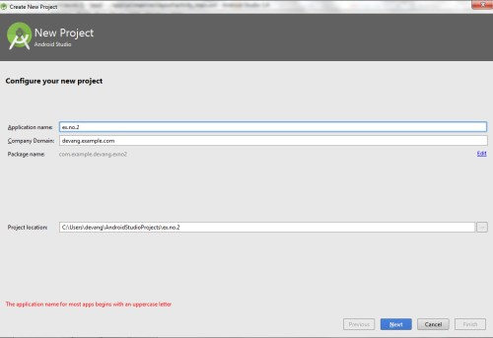

* Then select the **Minimum SDK** as shown below and click **Next**.

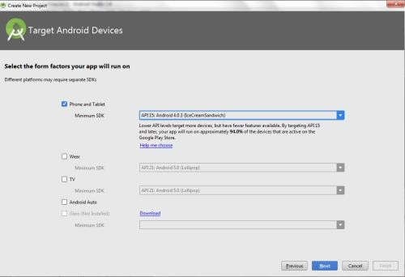

* Then select the **Empty Activity** and click **Next.**

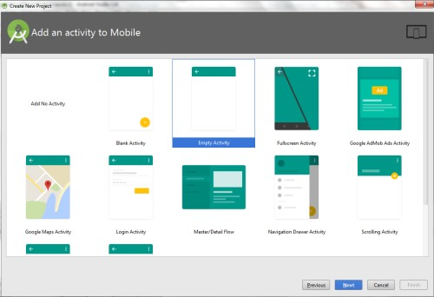

* Finally click F**inish**.

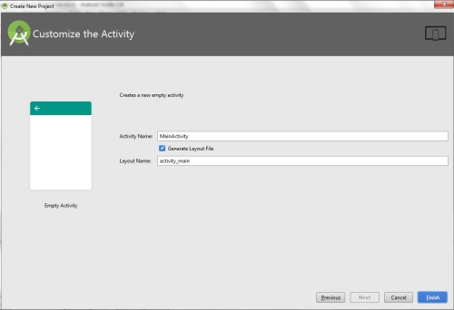

* It will take some time to build and load the project.
* After completion it will look as given below.

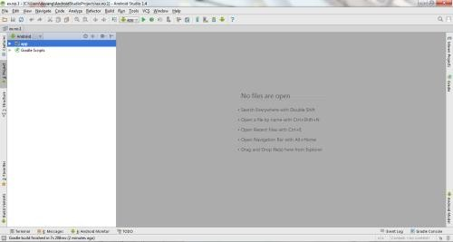

**Creating Second Activity for the Android Application:**

* Click on **File -> New -> Activity -> Empty Activity.**

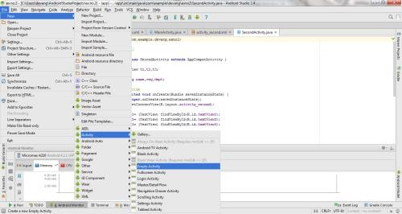

* Type the Activity Name as **SecondActivity** and click **Finish** button.

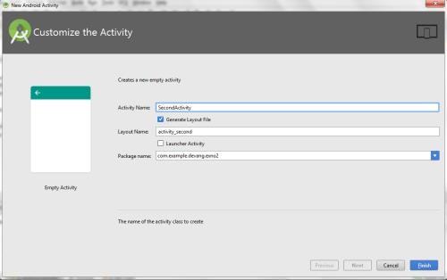

* Thus Second Activity For the application is created.

**Designing layout for the Android Application:**

***Designing Layout for Main Activity:***

* Click on **app -> res -> layout -> activity_main.xml.**

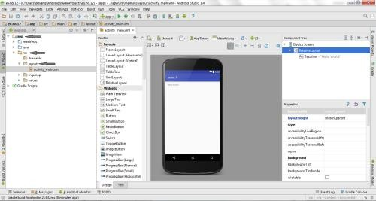

* Now click on **Text** as shown below.

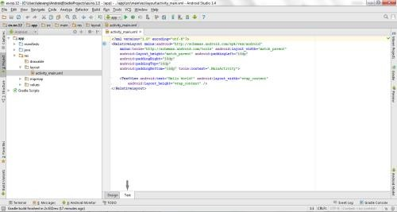

* Then delete the code which is there and type the code as given below.

##### Code for Activity_main.xml:

<?xml version="1.0" encoding="utf-8"?>

<RelativeLayout [xmlns:android="http://schemas.android.com/apk/res/android"](http://schemas.android.com/apk/res/android) xmln[s:tools="http://schemas.android.com/tools"](http://schemas.android.com/tools) android:layout_width="match_parent" android:layout_height="match_parent"

tools:context=".MainActivity">

<LinearLayout

android:layout_width="match_parent" android:layout_height="100dp">

<TextView

android:id="@+id/textView" android:layout_width="match_parent" android:layout_height="wrap_content" android:layout_margin="30dp" android:text="Details Form"

android:textSize="25sp" android:gravity="center"/>

</LinearLayout>

<GridLayout

android:id="@+id/gridLayout" android:layout_width="match_parent" android:layout_height="match_parent" android:layout_marginTop="100dp" android:layout_marginBottom="200dp" android:columnCount="2" android:rowCount="3">

<TextView

android:id="@+id/textView1" android:layout_width="wrap_content" android:layout_height="wrap_content" android:layout_margin="10dp" android:layout_row="0" android:layout_column="0" android:text="Name" android:textSize="20sp" android:gravity="center"/>

<EditText

android:id="@+id/editText" android:layout_width="wrap_content" android:layout_height="wrap_content" android:layout_margin="10dp" android:layout_row="0" android:layout_column="1" android:ems="10"/>

<TextView

android:id="@+id/textView2" android:layout_width="wrap_content" android:layout_height="wrap_content" android:layout_margin="10dp" android:layout_row="1" android:layout_column="0" android:text="Reg.No" android:textSize="20sp" android:gravity="center"/>

<EditText

android:id="@+id/editText2" android:layout_width="wrap_content" android:layout_height="wrap_content" android:layout_margin="10dp" android:layout_row="1" android:layout_column="1" android:inputType="number" android:ems="10"/>

<TextView

android:id="@+id/textView3" android:layout_width="wrap_content" android:layout_height="wrap_content" android:layout_margin="10dp" android:layout_row="2" android:layout_column="0"

android:text="Dept" android:textSize="20sp" android:gravity="center"/>

<Spinner

android:id="@+id/spinner" android:layout_width="wrap_content" android:layout_height="wrap_content" android:layout_margin="10dp" android:layout_row="2" android:layout_column="1" android:spinnerMode="dropdown"/>

</GridLayout>

<Button

android:id="@+id/button" android:layout_width="wrap_content" android:layout_height="wrap_content" android:layout_alignParentBottom="true" android:layout_centerInParent="true" android:layout_marginBottom="150dp" android:text="Submit"/>

</RelativeLayout>

* Now click on Design and your activity will look as given below.

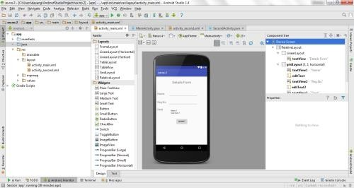

* So now the designing part of Main Activity is completed.

***Designing Layout for Second Activity:***

* Click on **app -> res -> layout -> activity_second.xml.**

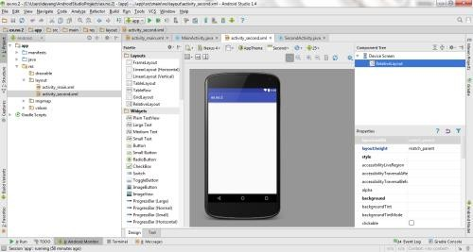

* Now click on **Text** as shown below.

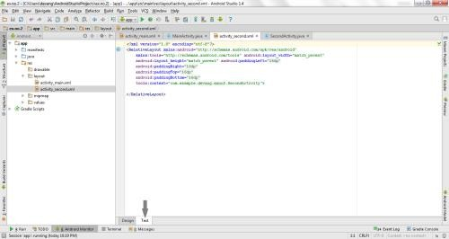

* Then delete the code which is there and type the code as given below.

##### Code for Activity_second.xml:

<?xml version="1.0" encoding="utf-8"?>

<LinearLayout [xmlns:android="http://schemas.android.com/apk/res/android"](http://schemas.android.com/apk/res/android) [xmlns:tools="http://schemas.android.com/tools"](http://schemas.android.com/tools) android:layout_width="match_parent" android:layout_height="match_parent" tools:context="com.example.devang.exno2.SecondActivity" android:orientation="vertical"

android:gravity="center">

<TextView

android:id="@+id/textView1" android:layout_width="wrap_content" android:layout_height="wrap_content" android:layout_margin="20dp" android:text="New Text" android:textSize="30sp"/>

<TextView

android:id="@+id/textView2" android:layout_width="wrap_content" android:layout_height="wrap_content" android:layout_margin="20dp" android:text="New Text" android:textSize="30sp"/>

<TextView

android:id="@+id/textView3" android:layout_width="wrap_content" android:layout_height="wrap_content" android:layout_margin="20dp" android:text="New Text" android:textSize="30sp"/>

</LinearLayout>

* Now click on Design and your activity will look as given below.

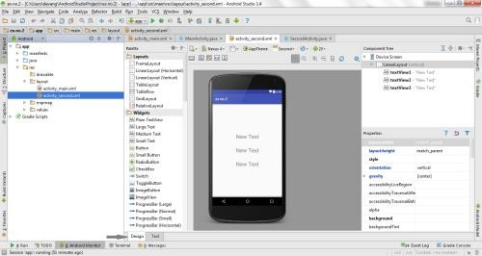

* So now the designing part of Second Activity is also completed.

**Java Coding for the Android Application:**

***Java Coidng for Main Activity:***

* Click on **app -> java -> com.example.exno2 -> MainActivity.**

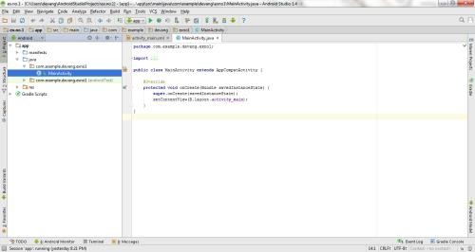

* Then delete the code which is there and type the code as given below.

##### Code for MainActivity.java:

package com.example.exno2; import android.content.Intent;

import android.support.v7.app.AppCompatActivity; import android.os.Bundle;

import android.view.View;

import android.widget.ArrayAdapter; import android.widget.Button; import android.widget.EditText; import android.widget.Spinner;

public class MainActivity extends AppCompatActivity {

//Defining the Views EditText e1,e2; Button bt;

Spinner s;

//Data for populating in Spinner

String [] dept_array={"CSE","ECE","IT","Mech","Civil"}; String name,reg,dept;

@Override

protected void onCreate(Bundle savedInstanceState) { super.onCreate(savedInstanceState); setContentView(R.layout.activity_main);

//Referring the Views

e1= (EditText) findViewById(R.id.editText); e2= (EditText) findViewById(R.id.editText2);

bt= (Button) findViewById(R.id.button); s= (Spinner) findViewById(R.id.spinner);

Spinner

//Creating Adapter for Spinner for adapting the data from array to

ArrayAdapter adapter= new

ArrayAdapter(MainActivity.this,android.R.layout.simple_spinner_item,dept_array

);

s.setAdapter(adapter);

//Creating Listener for Button bt.setOnClickListener(new View.OnClickListener() {

@Override

public void onClick(View v) {

//Getting the Values from Views(Edittext & Spinner) name=e1.getText().toString(); reg=e2.getText().toString(); dept=s.getSelectedItem().toString();

//Intent For Navigating to Second Activity

Intent i = new Intent(MainActivity.this,SecondActivity.class);

//For Passing the Values to Second Activity i.putExtra("name_key", name); i.putExtra("reg_key",reg); i.putExtra("dept_key", dept);

startActivity(i);

}

});

}

}

* So now the Coding part of Main Activity is completed.

***Java Coding for Second Activity:***

* Click on **app -> java -> com.example.exno2 -> SecondActivity.**

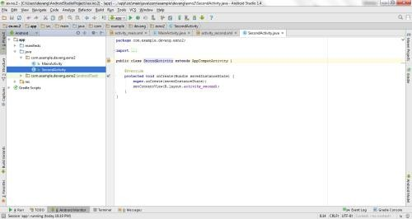

* Then delete the code which is there and type the code as given below.

##### Code for SecondActivity.java:

package com.example.exno2; import android.content.Intent;

import android.support.v7.app.AppCompatActivity; import android.os.Bundle;

import android.widget.TextView;

public class SecondActivity extends AppCompatActivity { TextView t1,t2,t3;

String name,reg,dept;

@Override

protected void onCreate(Bundle savedInstanceState) { super.onCreate(savedInstanceState); setContentView(R.layout.activity_second);

t1= (TextView) findViewById(R.id.textView1); t2= (TextView) findViewById(R.id.textView2); t3= (TextView) findViewById(R.id.textView3);

//Getting the Intent Intent i = getIntent();

//Getting the Values from First Activity using the Intent received name=i.getStringExtra("name_key"); reg=i.getStringExtra("reg_key"); dept=i.getStringExtra("dept_key");

//Setting the Values to Intent t1.setText(name); t2.setText(reg); t3.setText(dept);

}

}

* So now the Coding part of Second Activity is also completed.
* Now run the application to see the output.

##### Output:

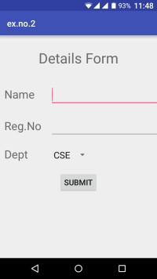 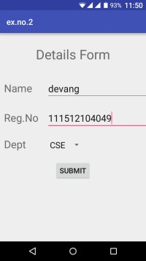 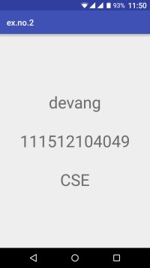

##### Result:

Thus a Simple Android Application that uses Layout Managers and Event Listeners is developed and executed successfully.

##### EXERCISE 2.1:

Execute the above exercise of Layout Manager and Event Listener in Android studio and show the exact GUI output? [2]

##### TASK 2.1

Develop an android application to display Toast on clicking a button. This should be a customize button which includes setGravity and setMargin?

##### EXERCISE 2.2:

Develop an android application By using Implicit and Explicit Intent. By using Implicit intent, A web page should be open in a web browser. Also call 2nd activity from the first activity by using explicit intent. [8]

##### RESOURCES:

<https://www.codingconnect.net/mobile-application-development-lab/> <https://www.javatpoint.com/android-tutorial> <https://www.tutorialspoint.com/android> <https://developer.android.com/guide> [Https://developer.Android.com/training/basics/firstapp/creating-project](https://developer.android.com/training/basics/firstapp/creating-project)

[Https://www.raywenderlich.com/120177/beginning-Android-development-tutorial-](https://www.raywenderlich.com/120177/beginning-Android-development-tutorial-installingAndroid-studio) [installingAndroid-studio](https://www.raywenderlich.com/120177/beginning-Android-development-tutorial-installingAndroid-studio) <https://www.youtube.com/playlist?list=PLS1QulWo1RIbb1cYyzZpLFCKvdYV_yJ-E> [Https://www.udemy.com/java-tutorial/](https://www.udemy.com/java-tutorial/)

[Https://www.w3schools.com/xml/](https://www.w3schools.com/xml/) [Http://www.Androidguys.com/](http://www.androidguys.com/)